Brand voice:
- A brand's voice reflects its personality and values, which is essential for clear communication and strong brand identity.
- Pega GenAI creates personalized, compliant content using data-driven insights, automating adherence to brand voice and style guidelines.
- The Brand Voice landing page helps you set and update global directives, create and test brand voice, ensuring consistent and authentic communication
Steps to create brand voice:
- Create Global directives
  - to define brand guidelines for tone and style across all communications by using Global Directives.
  - Login with businessuser
  - 
  - 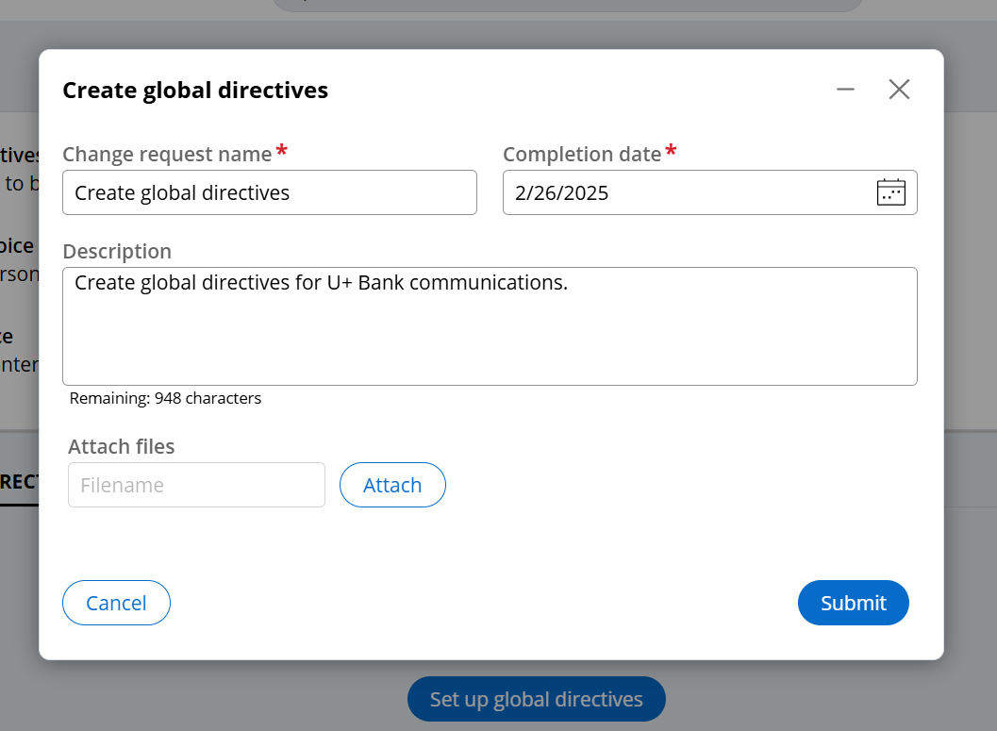
  - 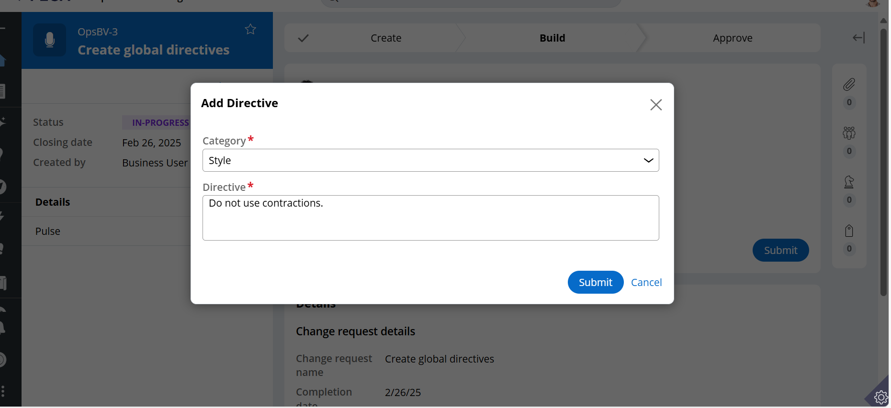
  - 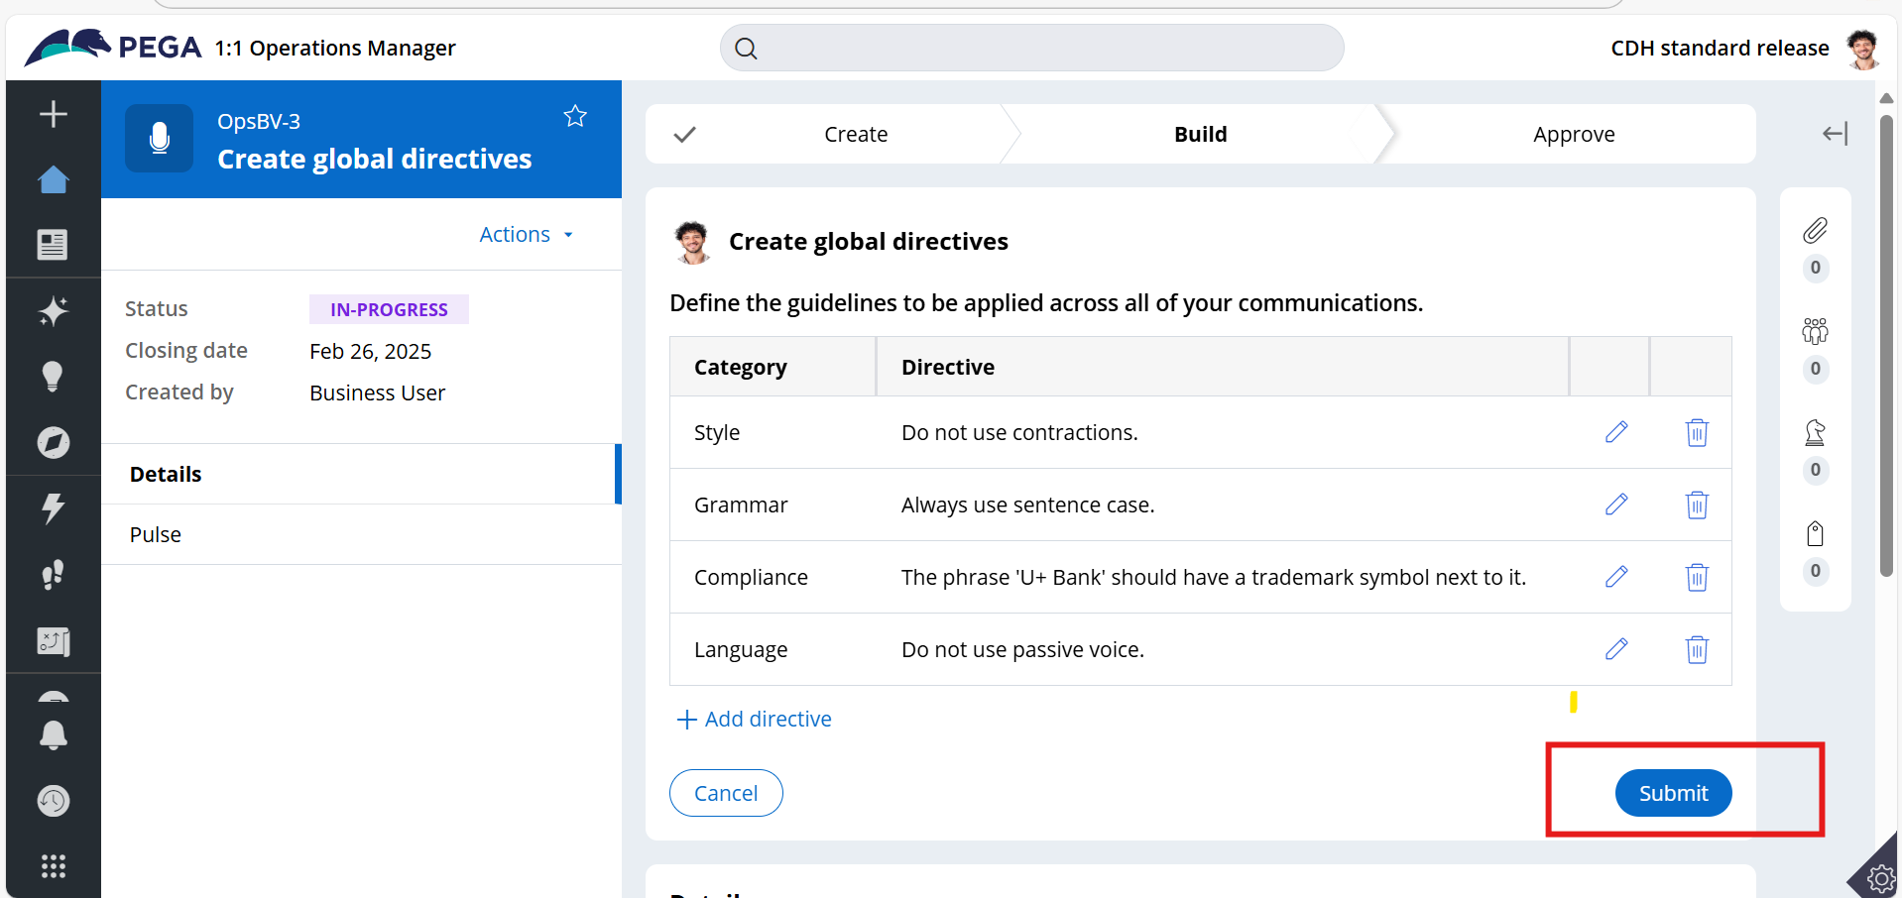
  - Logoff from businessuser
- Approve Global directives
  - Login with Team lead for approval process
  - 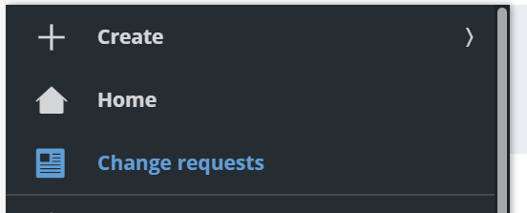
  - 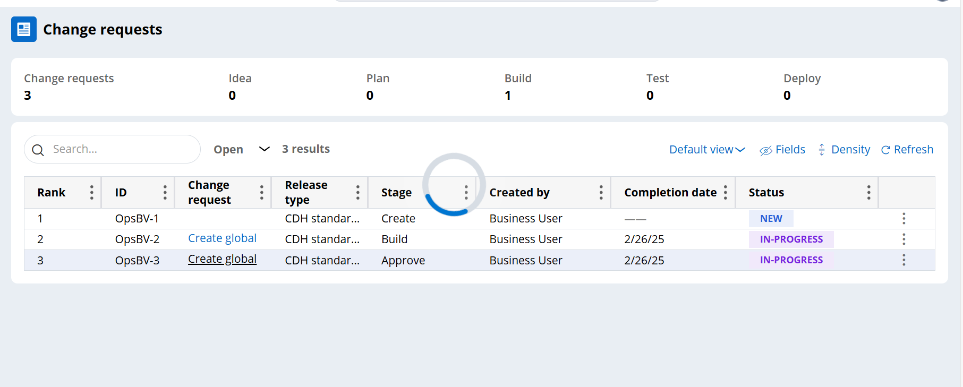
  - Click on create global
  - 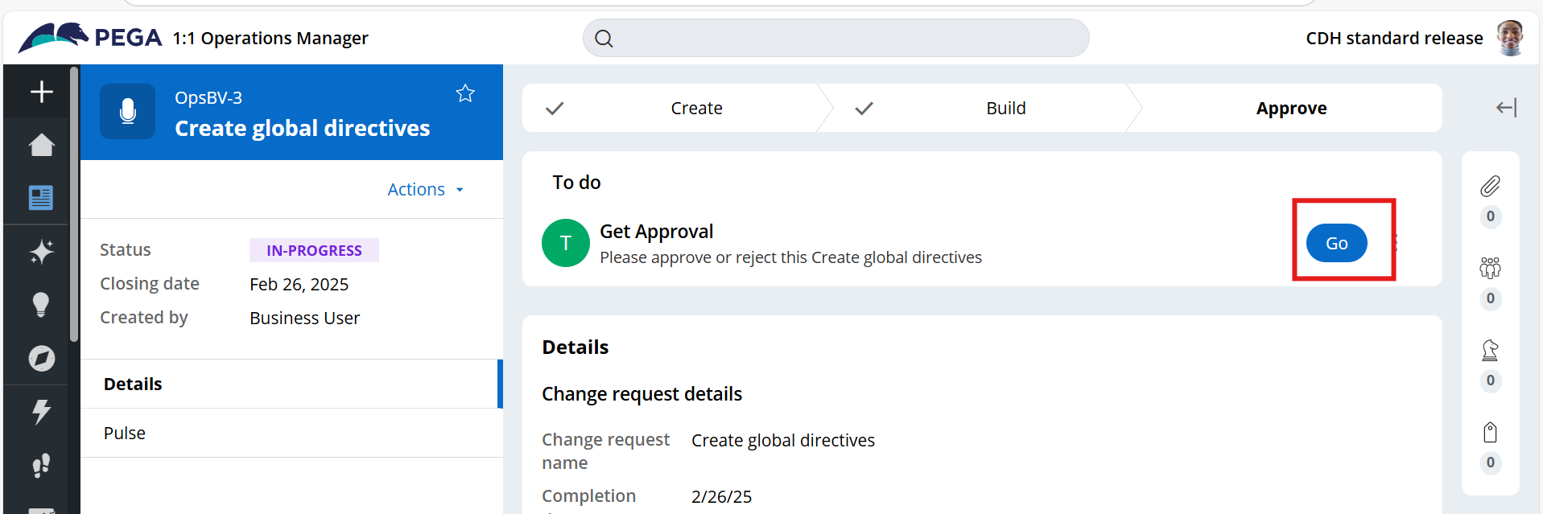
  - 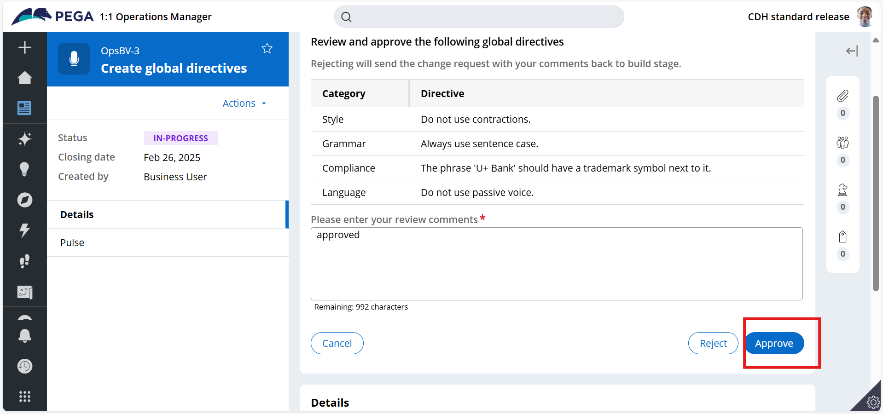
  - logoff
- Create Brand voice
  - Login with business user
  - Click on create brand voice
  - 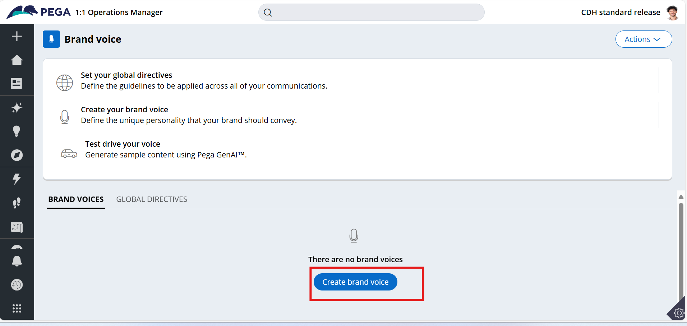
  - 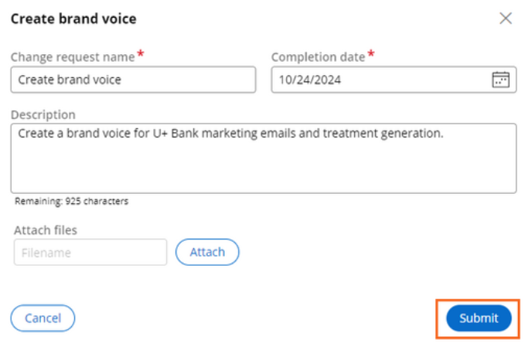
  - Enter details and click show additional configuration
  - 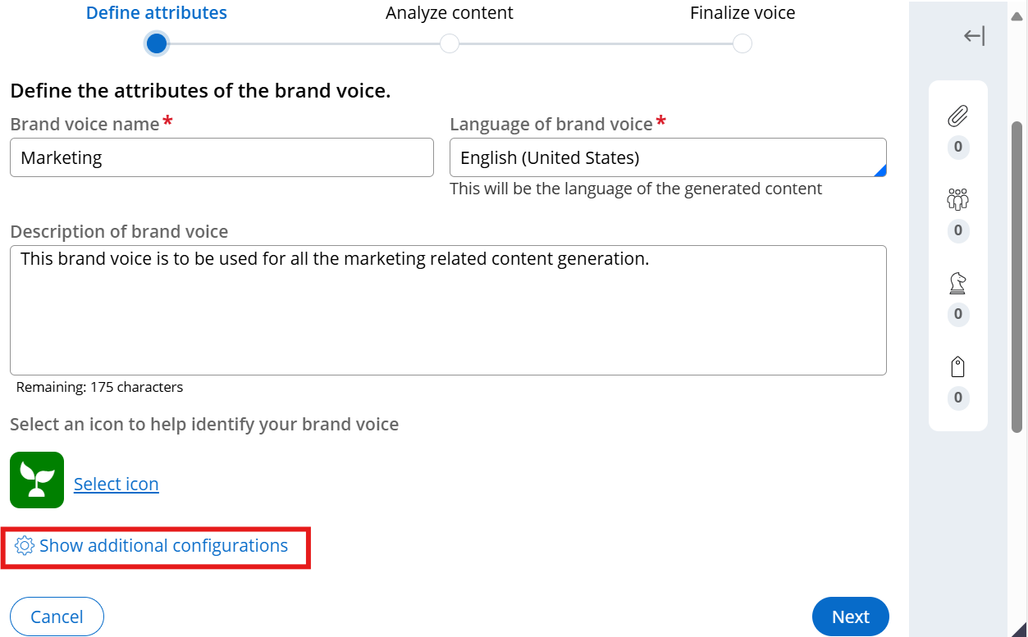
  - 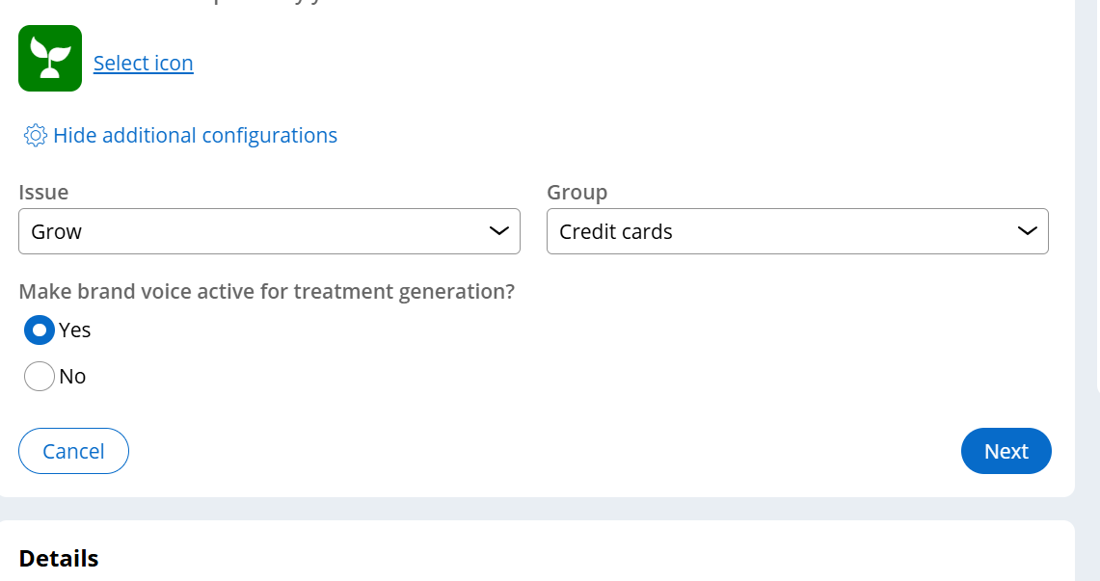
  - Click on next
  - 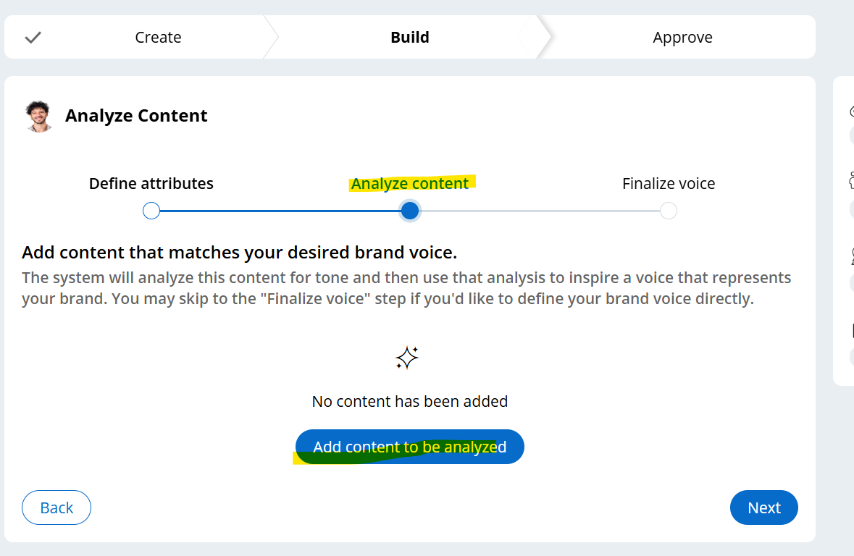
  - 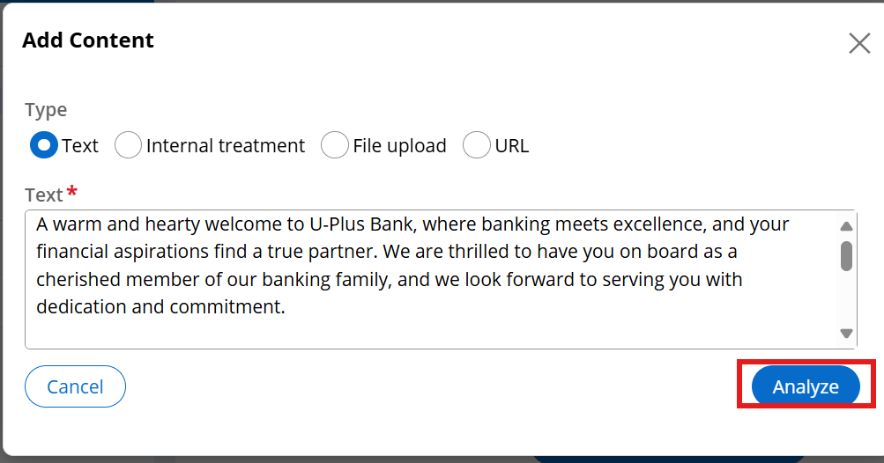
  - 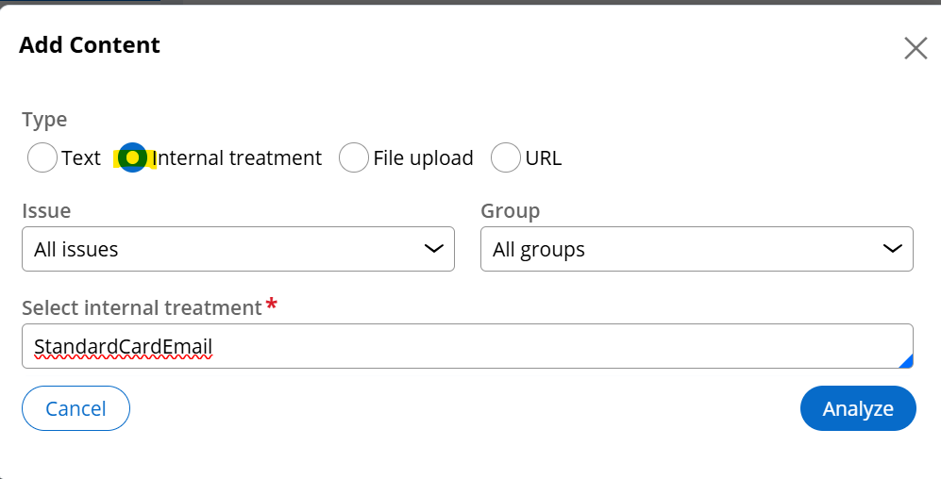
  - Click on analyze and next
  - 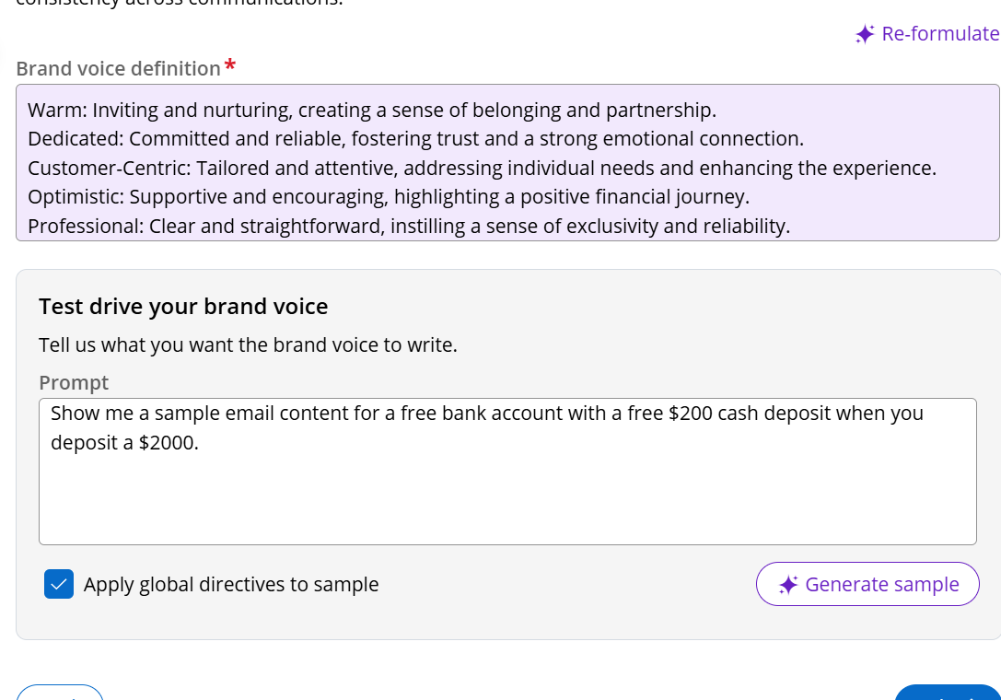
  - Generate sample
  - 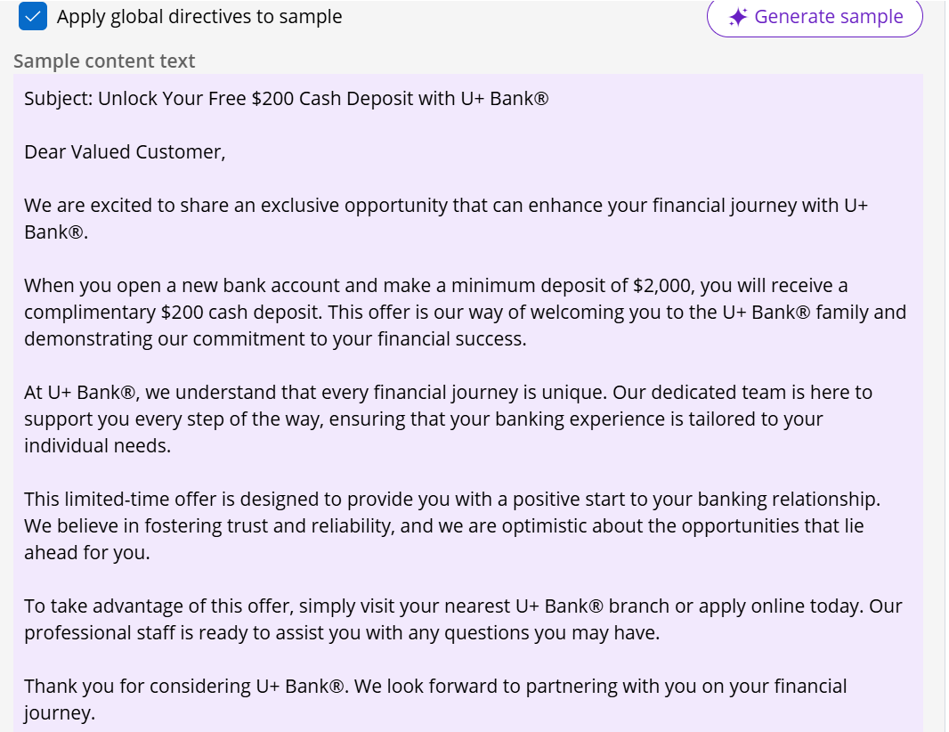
  - Click on submit
  - 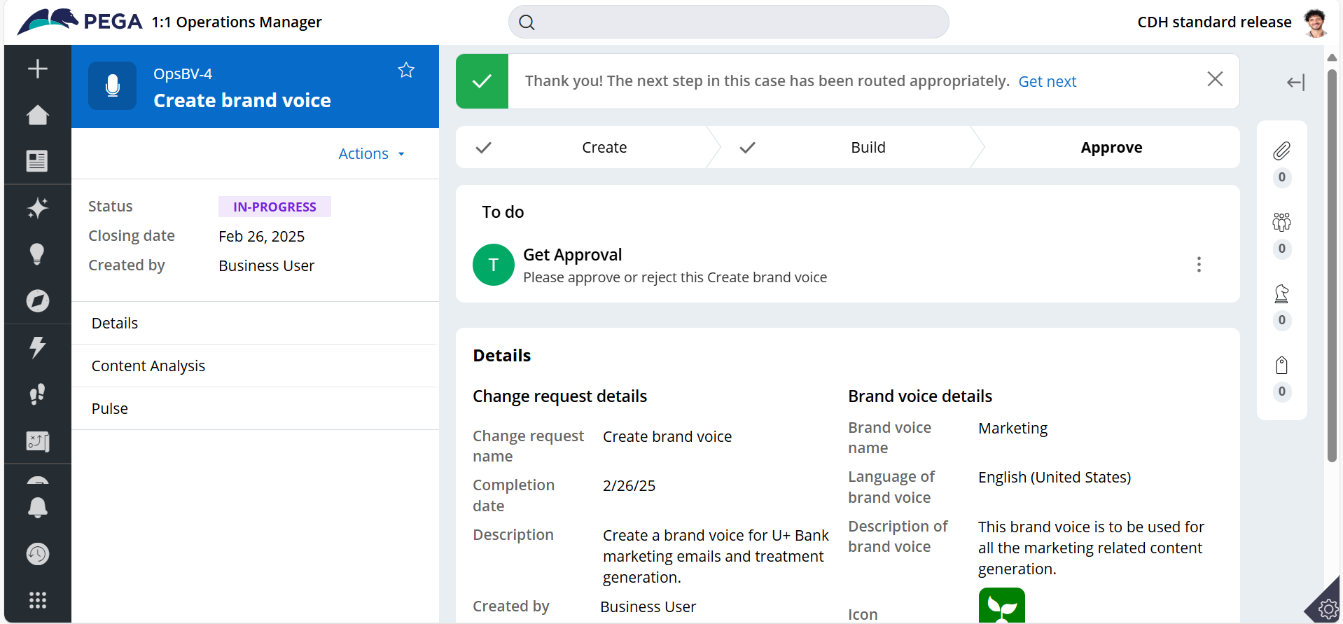
  - logout
- Approve Brand voice
  - Login as team lead
  - Click on change request
  - 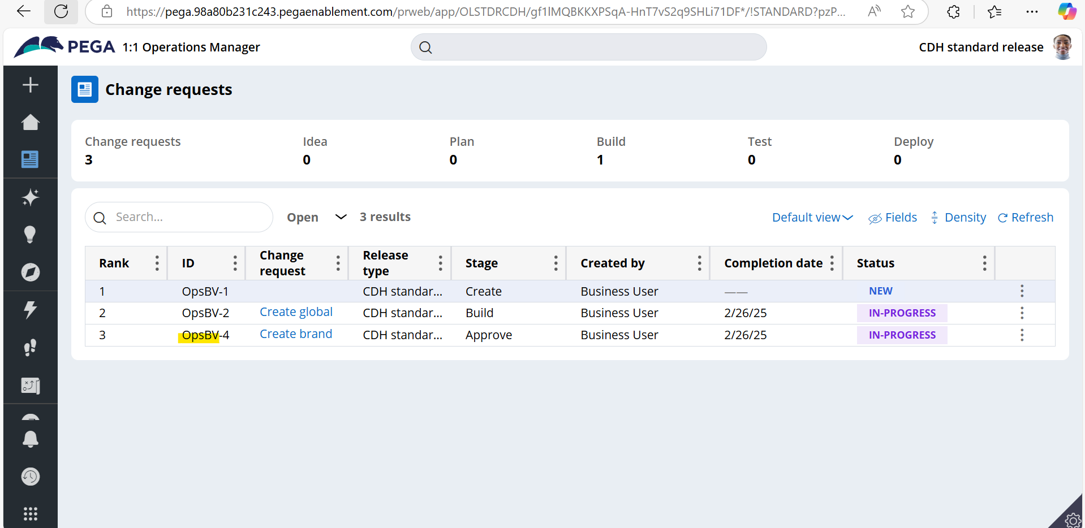
  - 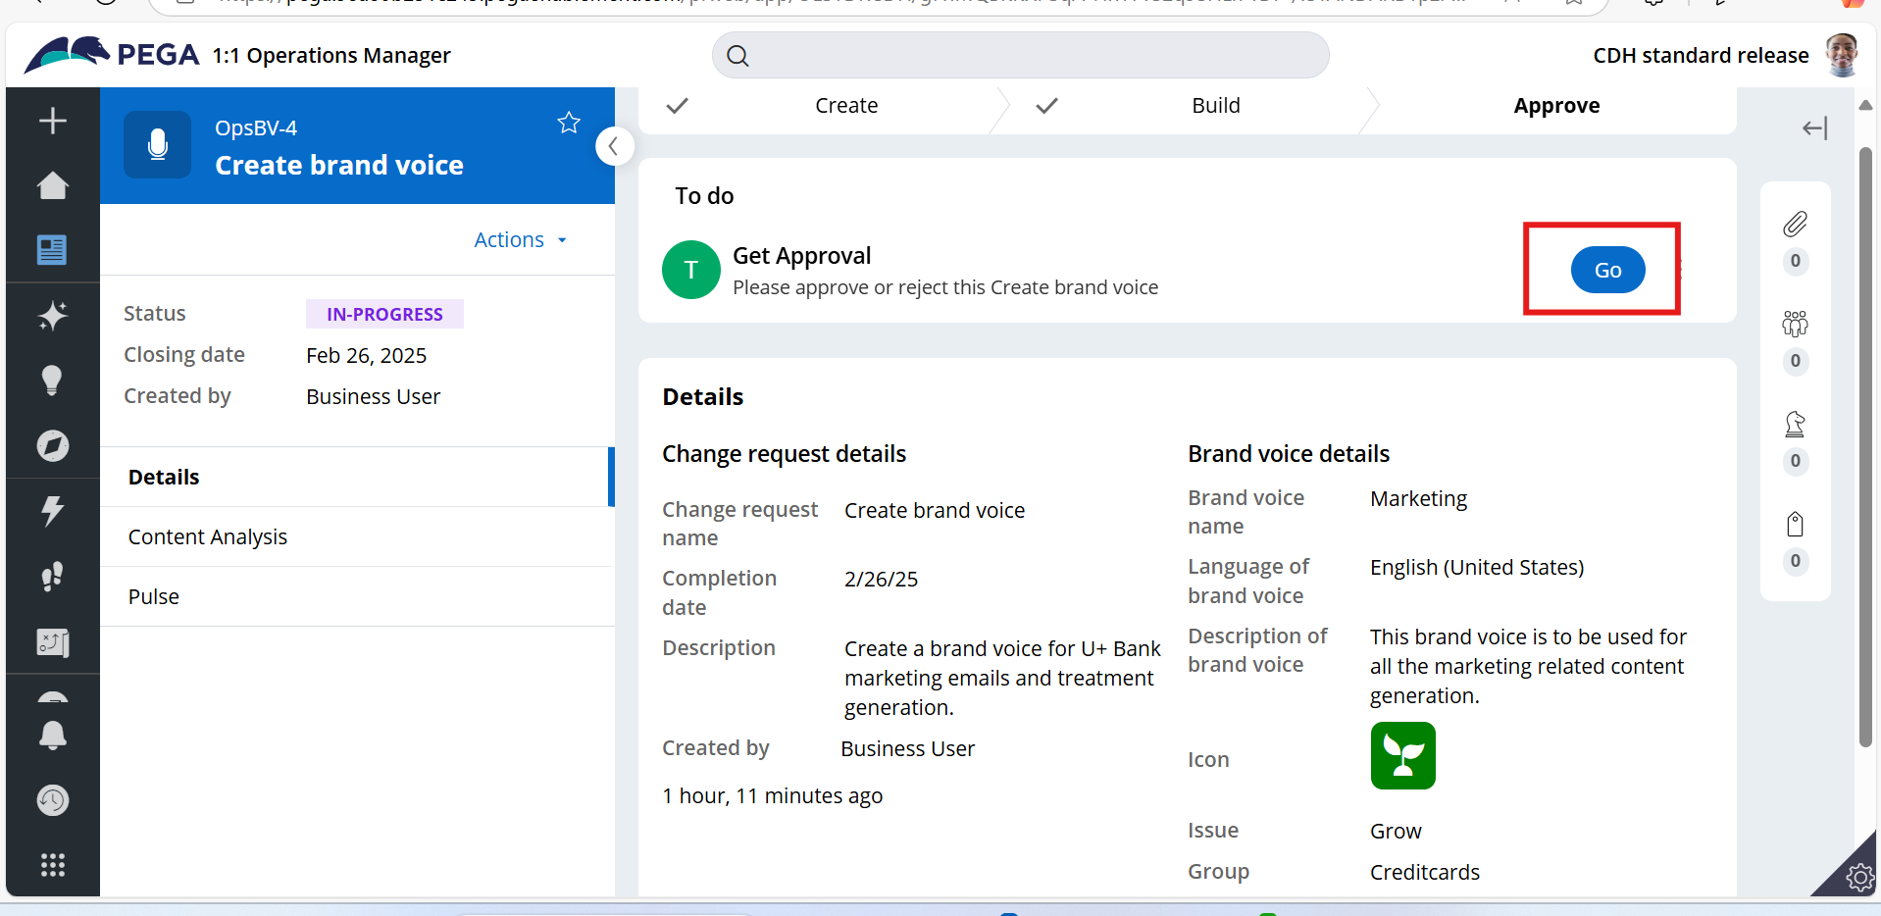
  - Click on go
  - 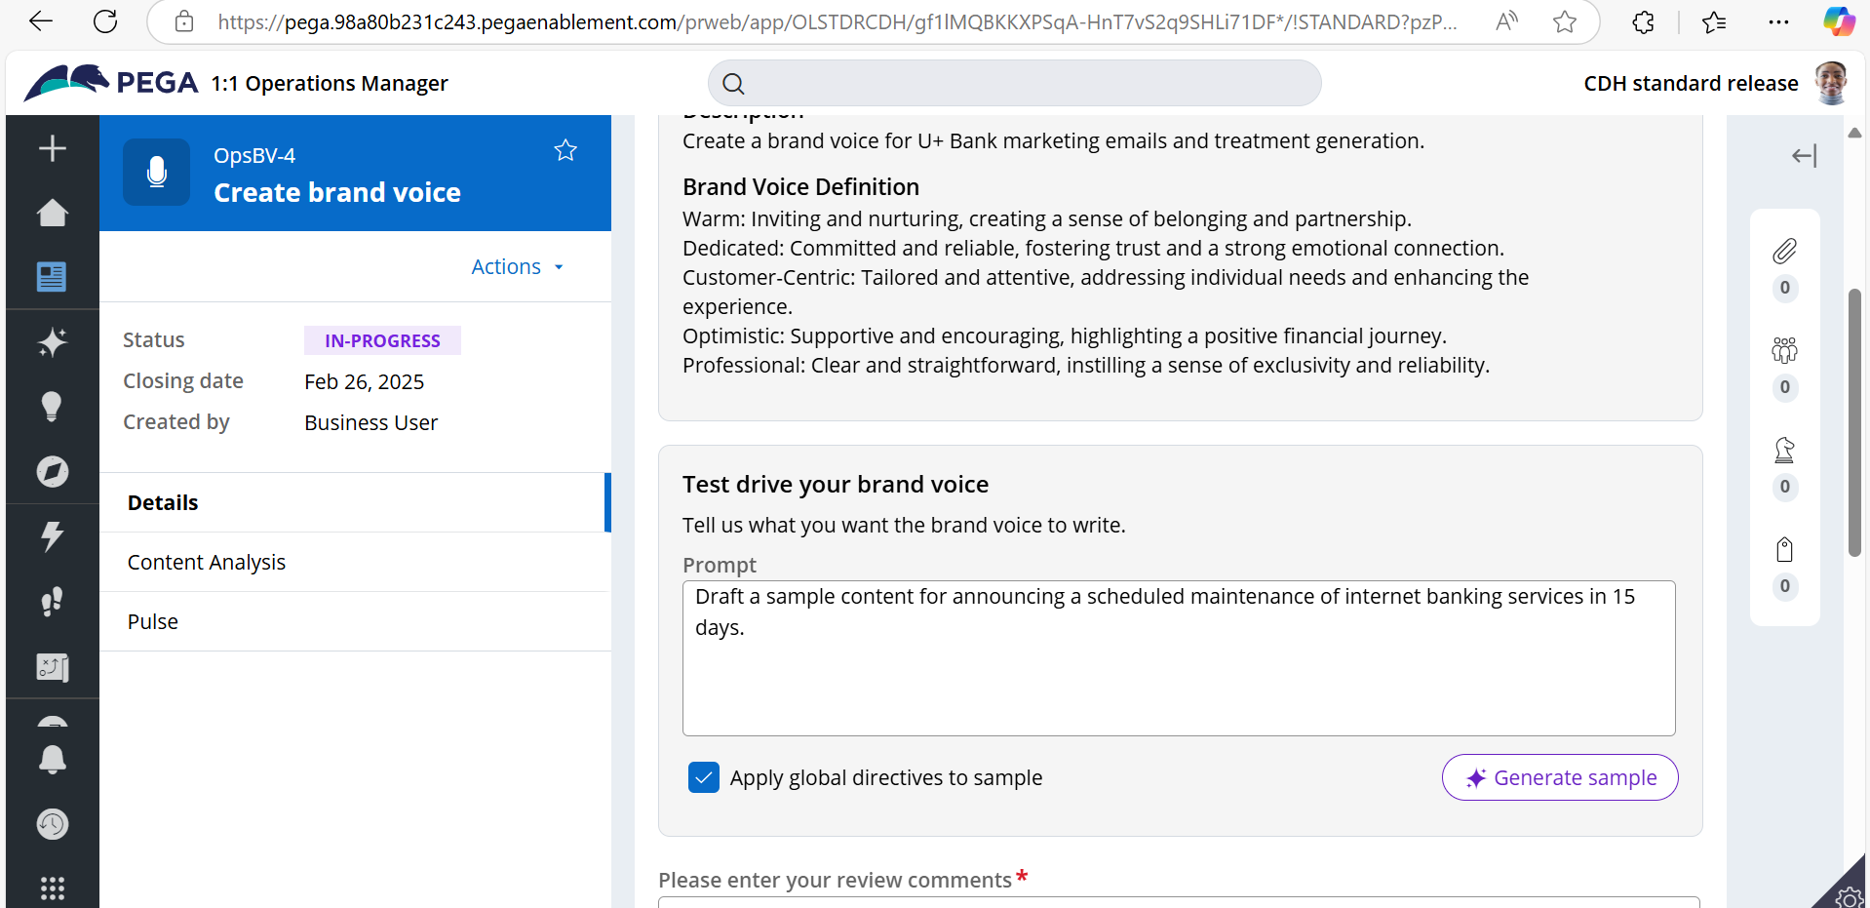
  - Enter sample text like “Draft a sample content for announcing a scheduled maintenance of internet banking services in 15 days.”
  - Click on generate sample
  - 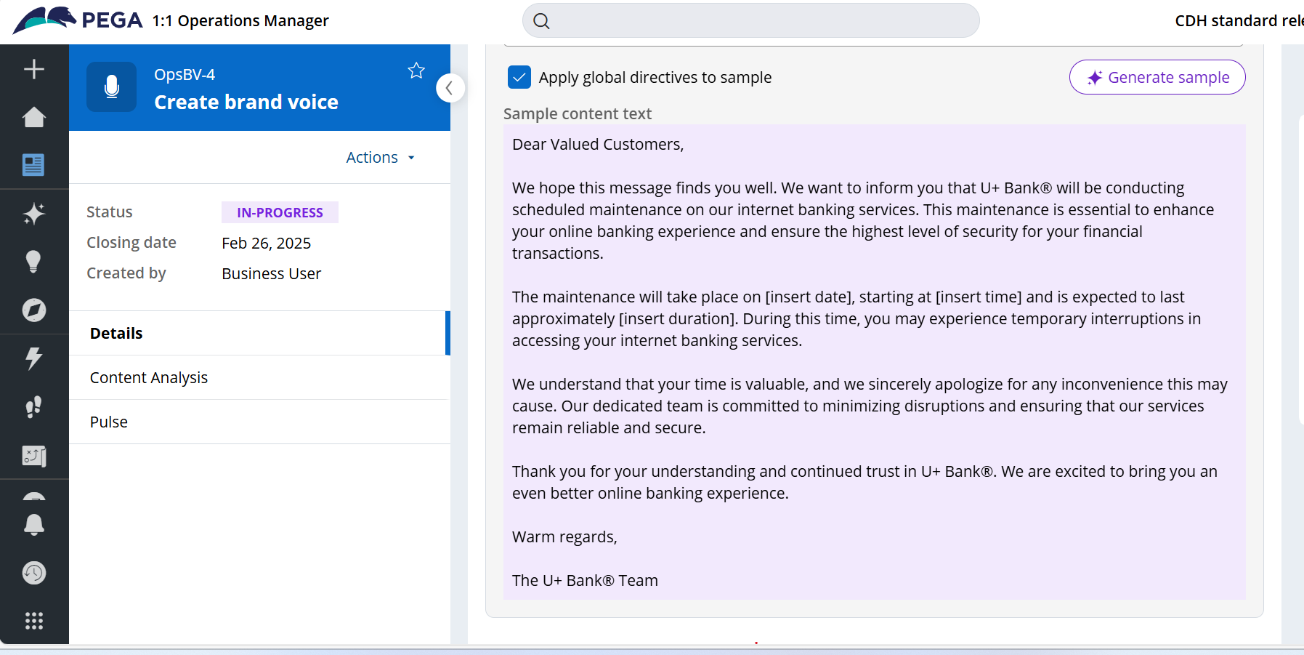
  - 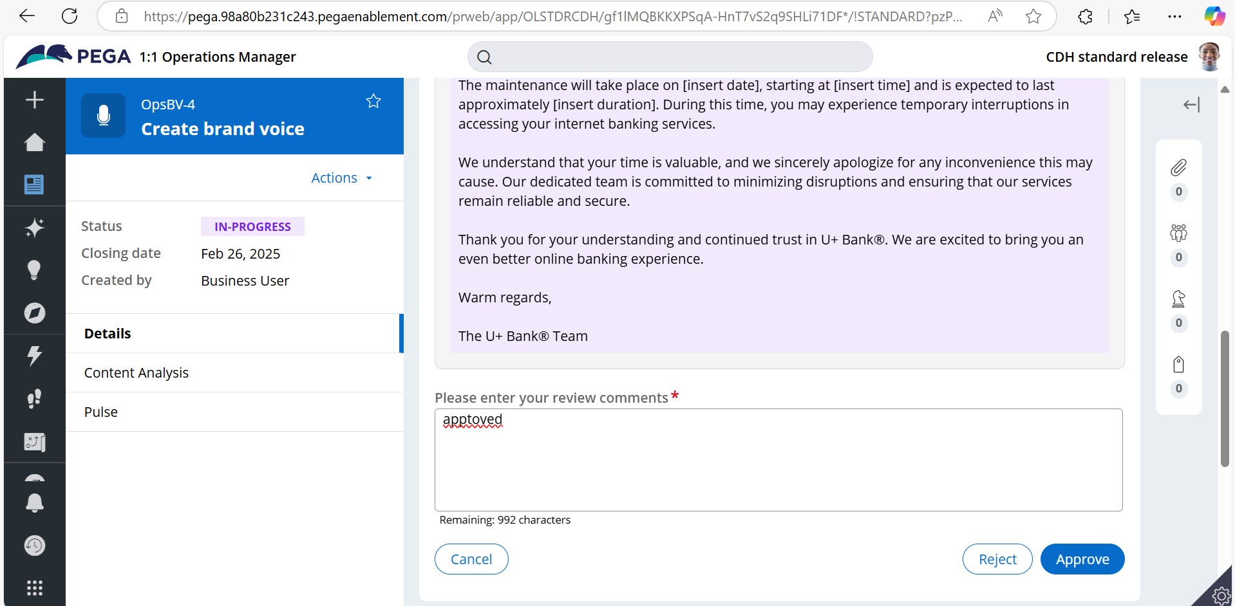
  - Click on approve
- Testing
  - Login as business user
  - 
   